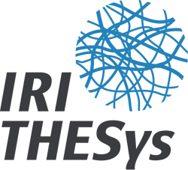**Application Form THESys Award**

IRI THESys – Integrative Research Institute on Transformations

of Human-Environment Systems, Humboldt-Universität zu Berlin

Please complete the form in English or German!

**Personal information of the student**

First name Last name

E-mail

**Bachelor/ Master project**

Title/topic

Date of submission

*(dd/mm/yyyy)*

Final grade

Supervisors

*(name)*

*(institute)*

*(name)*

*(institute)*

*(name)*

*(institute)*

Program title/ Name of study program

Institute

**Bachelor degree** (if applicable)

University

*(name/city/country)*

Institute Date of degree

*(dd/mm/yyyy)*

Program title

**Contribution of your Bachelor/Master Thesis to IRI THESys Research**

Please answer the following three questions regarding to the THESys Award selection criteria:

1. How does your topic relate to one or more of the research themes of IRI THESys *(land use change, integrative food systems, global water cycles, climate change adaptation, and infrastructures)*? (max 1000 characters)

2. What role do interdisciplinary research approaches and/or transdisciplinary research approaches play in your Bachelor/Master thesis? (max 1000 characters)

3. How could your Bachelor/Master thesis potentially contribute to transforming the society into a more sustainable one? (max 1000 characters)

Date/ Signature of student:

**The following section shall be provided by one of your supervisors.**

**Letter of Support** (completed by supervisor)

Please outline why the present work states an excellent student work in the context of human-environment research. (max. 2.500 characters)

Name of supervisor

Date/Signature of supervisor: